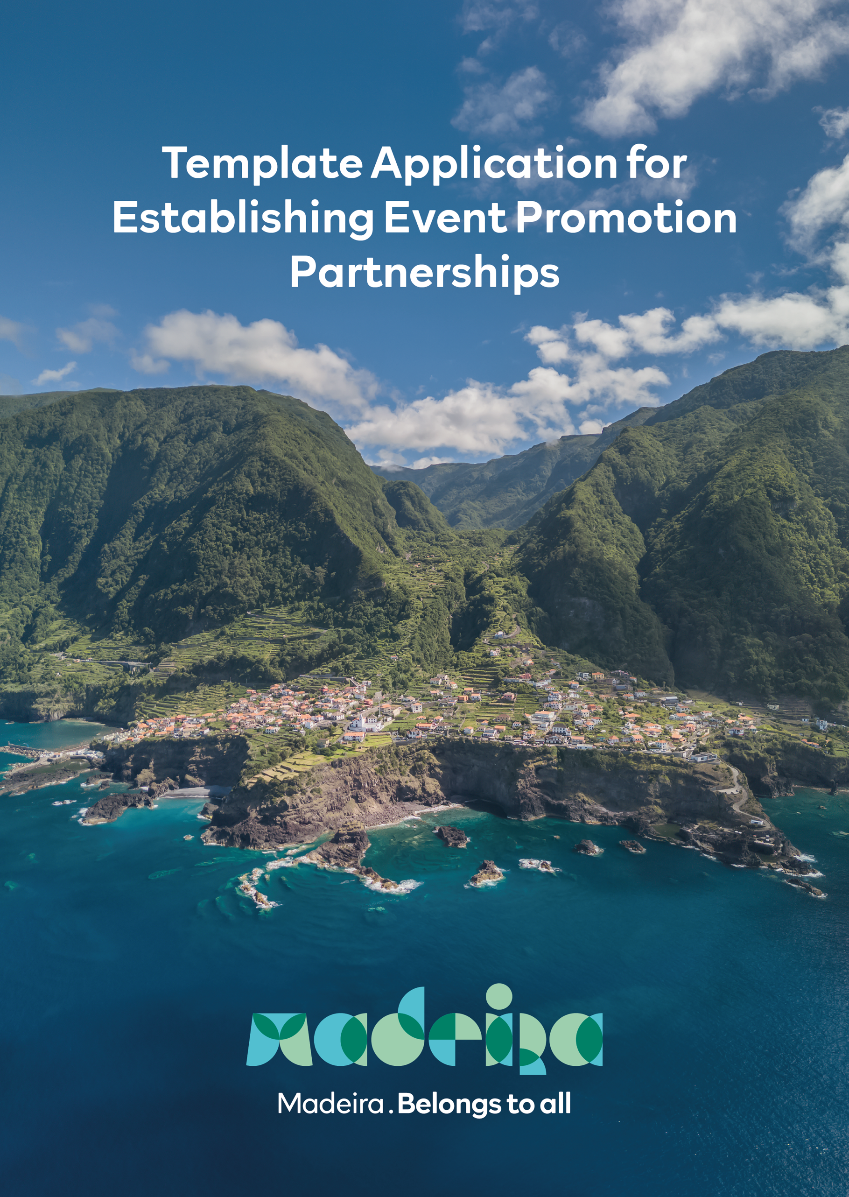

The Template Application for Establishing Event Promotion Partnerships with AP Madeira, aimed at promoting regional events, is a document that allows aggregating key information with a view to assessing these events as comprehensively as possible.

Thus, the granting of support by AP Madeira will depend on the information provided below, and the greater the detail, the greater the probability of increasing the total amount to be supported, especially in the points highlighted in red.


Therefore, we ask for your collaboration in completing this form, which is mandatory for calculating and validating the amounts to be granted.

Template Application for Establishing Event Promotion Partnerships
ORGANIZATION DETAILS

Company Name:

Adress:

Type of Organization:

Enterprise
Association
Non-Governmental institution
DMC
Outro

Representative:
Title:
Email:
Contact:

RNAAT/RNAVT n.º: _______________ (if applicable)

VAT Identification number: _______________

TO BE FILLED BY APM:
Idok number: _____________

1 - Event Information
Event Identification and Description:
Type of Event (Sports/Musical/Cultural...):
Event Date and Duration:
Event Venue:
Estimated revenue from/expenses with the event:

Total Participants in the last edition of the event, by nationality, counting regional and national participants separately:

Total Participants in the next edition of the event, by nationality, counting regional and national participants separately (estimate):

Does the event promote good practices related to sustainability? Please specify.

2 - Projection and Notoriety of the Event

Event Media/Communication Plan
List of Media/Influencers covering the event (mandatory information):

Markets of Origin of the Media/Influencers (mandatory information):

Relevance and Reach of the Media/Influencers
- Estimated AVE, in € (highly valued information):

- Estimated Reach, in number of people (highly valued information):

- Print Run:

- Number of Subscribers:

- Other relevant indicators for analysis:

What type of content will be produced and publicised by the Media/Influencers (Text/Photo/Video?)

Is it possible to transfer these contents for use by AP Madeira and its partners?

Are the media/influencers available to share official Destination Madeira Tags and Hashtags on their social media?

Is the organisation available to include the Destination's Official Logos in Event Communication and Promotional Materials?

3 - Event Support
Goals/Purpose of the Support for which you are applying:

Type of Support (Financial/Logistics/Communications):

Amount of Support sought:

Entity that will benefit from the Support:

4 – CONSIDERATIONS

We request confirmation of the following considerations whenever applicable:

Considerations | Agree
Presence of the Madeira Brand in all public relations activities, marketing and promotional material as official support/partner of the event (press releases, support to journalists, or others within the scope of PR);
Inclusion of the Madeira Brand in all promotional materials related to the event (website, poster, advertising inserts, brochures, among others);
The events that promote strategic products, as MOT & MGP must also be included and which we urge you to make good use of it;
Institutional video of the destination to be broadcast at the opening ceremony and on other available media;
Roll Ups / Beach Flags / Tarpaulins to be placed strategically in the event locations – The organisations of the event should propose where to be placed and the quantities;
Distribution of promotional materials, if applicable to the logistical structure of the event, to be included in a Welcome Kit. Note: the materials would be provided by APM upon availability;
Sustainable measures to be implemented whenever possible (environmentally friendly materials, reduction of plastics);
All Madeira Brand applications, whether graphic or content, must be previously approved by APM;
In cases where the Communication Plan provides for media coverage in the form of Articles / Sponsored Content / Newsletters / Press Releases in digital format, the dissemination of the event should be associated with Madeira Destination through a hyperlink to https://visitmadeira.com/, whenever Madeira is motioned; OR a paragraph at the end "For more information, visit the official website https://visitmadeira.com/ ";
Active communication on the social networks of the Madeira Brand and encouragement to all participants with active participation in the event (athletes, influencers, musicians, artists) to publicise the Destination and its products based on our Digital Kit;
The events that promote strategic products, as MOT & MGP must also be included and which we urge you to make good use of it;

5 –DOCUMENTS ATTESTING OBSERVANCE OF THE GENERAL PRECONDITIONS SET OUT IN PARAGRAPH 10, SECTION 1, SUBPARAGRAPH B) OF APM'S REGULATION FOR GRANTING SUPPORT FOR ATTRACTING, ORGANISING AND HOLDING EVENTS WITH HIGH POTENTIAL FOR TOURIST ATTRACTION OR MEDIA GENERATION FOR DESTINATION MADEIRA (HEREINAFTER "REGULATION")

We hereby declare for the purposes set out in in paragraph 3, section 6 of the Regulation that prior to applying to the financial contributions set out in the Regulation, all instruments in force at the time of the submission of this application for granting financial contributions created and promoted by Portuguese Tourism Board (or, in Portuguese, "Turismo de Portugal") were consulted (fill in where applicable)
and the event identified above was not granted with any financial aid by the Portuguese Tourism Board; or
and the event identified above was granted with financial aid by the Portuguese Tourism Board in the total amount of € ________________________.

Updated Tax clearance certificate or an Affidavit in lieu of such certificate (document attached)

Updated Social Security clearance certificate or an Affidavit in lieu of such certificate) (document attached)

Updated Company’s Certificate issued by the Registrar of Companies issued by the country’s legal authorities

Obligations of the Beneficiary/Organiser/Promoter of the event

The sole responsibility for holding the event, as described in your application, ensuring the following minimum considerations:

- Destination Madeira logo included in all official event communications, including publicity and communication materials and activities;
- E-mail marketing, prepared by APM and sent to the event participant database and disseminated by the Beneficiary/Organiser/Promoter of the event;
- Presence of the Madeira brand, clearly visible in the event's venues;
- Broadcast/screening of a video on destination Madeira at the opening ceremony of the event; and
- Mandatory dissemination of the Madeira Digital Kit among the participants of the event, especially among the main headliners, influencers or media; if the event has its own Digital Kit, it must include the information contained in the Madeira Digital Kit, namely social media tags and top 3 hashtags. The official social media page of the event shall also follow these guidelines, including the main Tags and Hashtags throughout the year.

Final notes
The basis for granting support and calculating the corresponding amount takes into account the following criteria:
(1) events with great international projection or with the potential to achieve one, namely (A) those that attract a significant number of foreign tourists to participate in them, or (B) those that manage to mobilise international media to promote and publicise them;
(2) definition of maximum support amounts, rather than fixed ones, since they are intended to cover expenses related to travel, accommodation, transfers, among others, incurred by opinion leaders in the Autonomous Region of Madeira, be they leading athletes, influencers, journalists or others, or costs related to the multimedia coverage of sporting events, namely with photographs or videos, in relation to which rights for APM shall also be ensured;
(3) events aimed at promoting tourism products and assets that are strategic for the Destination;
(4) events with a strong sustainability component;

